5 Minute Tennessee Coal Token Catalog
Tom Carson
Neal Burton and I have worked on identifying some coal mining mavericks. We identified the East Tennessee Mining Company Eureka Mines and Neal wrote a story for Talk’n Token. We then tackled the Roane Iron Company W which had been attributed to Wilder Tennessee. It turned out that both were iron mines in Roane County. The Roane Iron W was from their Commissary at the Wright(s) Slope Iron Mine. We even found several years county copies of Roane Iron Wright(S) Store Business License.
Neal was also working with Burley Williams on the latest edition of Edkins. I have been working with tokencatalog.com (TC.C) for several years and suggested that Edkin merge into TC.C. Updates can be made daily and if a printable catalog is needed it can be generated in 5 minutes.
Larry Loiseau and I have been working on getting coal tokens into TC.C. Mike Williams has furnished the ones from Roane County we needed and Larry has added a bunch from his collection. I have cropped all the images and removed the background. We have made major strides in getting them in alphabetical, denomination and series order.
This will show how an attractive – duplex print ready catalog can be generated in 5 minutes.
Login to TC.C and select Tennessee. In the Exact Phrase type Catalog-Edkins.
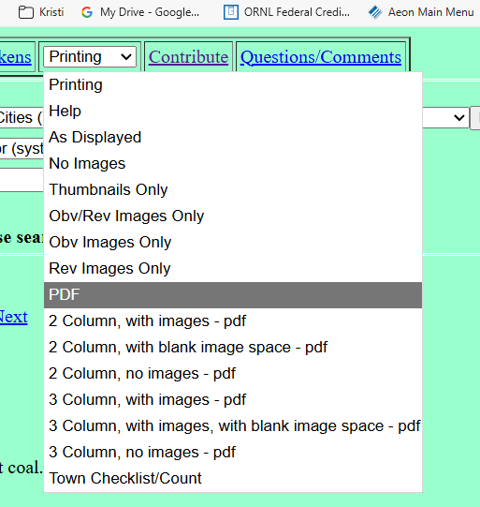
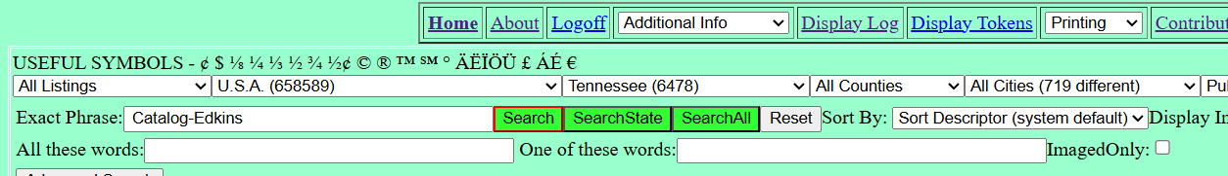
This will give you a listing of 792 – many with images.
Go to printing and choose PDF. I will also run and attach links to the 2 Column, with images – pdf.
A dialog will open to allow you to create a title page. Check the With Images and Include Title Page. There are more options to add features. Click Generate Catalog and in about 1 minute you have a catalog with color images. The catalog is print ready for duplex printing.
I generated bookmarks with Adobe Acrobat and the autobookmark plugin. This makes the electronic catalog a lot easier to use. The electronic catalog is also searchable. I can do this for a user if desired.
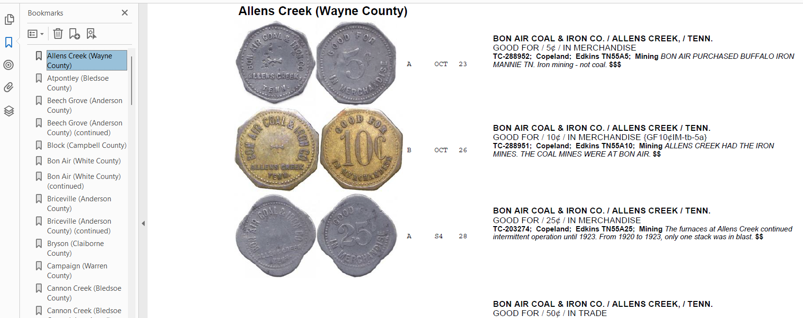
This screenshot is of the first page of catalog. It is a little ironic the tokens are for iron mining and furnace.
THIS LINK LETS YOU DOWNLOAD THE 101page catalog. It is less than 10 MB and below the size limits of all eMail system.
Here is an example of the 2 Column
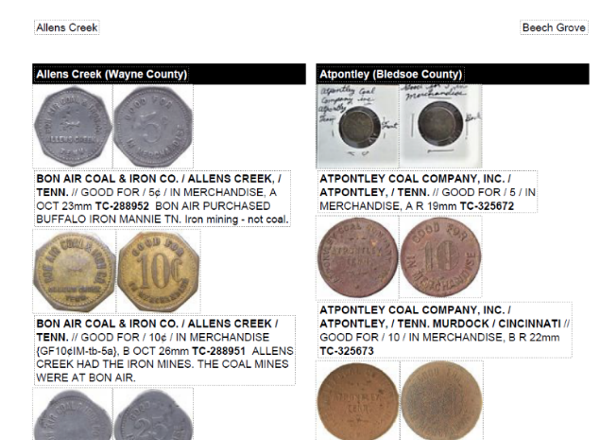
The 2 Column is a smaller file and is more for the print format.
THIS LINK WILL LET YOU DOWNLOAD THE 74 Page 2 Column file. It is less expensive to print since it has fewer pages.
If we all worked together, we would have something fantastic with no one having to do it all. There are a few keys. 1) good images – 300 dpi and 2) OUT OF 2X2. I will crop and remove backgrounds when you add them to TC.C. NOTE: I am only doing this for Tennessee.
Richard Greever developed tokencatalog.com as a tool we all can work together with. Over 12,000 people are registered users and 2,600 have contributed. It is free.
I have been working with Richard to add Mining to TC.C. Instead of Catalog-Edkins put in Catalog-Mining. This gets all mining not just coal. I am also adding the paper scrip. Before 1884 most of the scrip was paper. Roane Iron Company issued paper 1868-84, US currency and advance booklets 1884-1918, then metal scrip 1918 to closure in 1930.
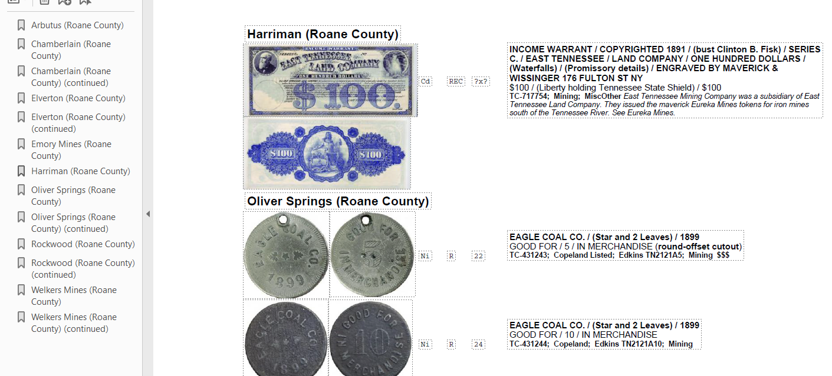
THIS LINK WILL ALOW YOU TO DOWNLOAD the Roane County Mining Catalog.
Give this some thought. Tom

